WHAT FLYING AT VALDORA WILL ACTUALLY LOOK LIKE
Suncoast Model Flyers – Development Application MCU26/0113 – 801–845 Dynes Road, Valdora

We are a local model aeroplane club, and we have applied to establish a permanent home at Valdora. This flyer sets out exactly how we intend to operate, so you can see for yourself what it will mean for you. If you have concerns, we would rather hear them from you directly than have you form a view from a distance.
What you can expect  Only two aircraft in the air at any one time. This is a rule we operate under, not a rough guide. However, many members are at the field, no more than two aircraft fly at once.  Electric aircraft only, with one exception. Two aircraft may fly together only if both are electric. Petrol or jet powered aircraft fly one at a time, and never alongside another aircraft.  At least 1.2 kilometres from 95% of nearby homes. The site was chosen for that distance. It was not the only site we looked at, but it put the most space between our activity and yours.  Aircraft stay inside the prescribed flying area. Aircraft must be flown within a defined area and within sight of the pilot at all times. We do not fly over neighbouring properties. Members who breach this face suspension.  Around 110 days a year are too wet to fly. In practice, flying is concentrated on fine mornings rather than spread evenly across the year.  If something bothers you, tell us  We would rather fix a problem than have it become a complaint to Council.  If noise, aircraft behaviour or anything else concerns you, contact us directly and we will respond within 5 business days. We will keep a record of every concern raised and what we did about it.  Mark Stringer President    Phone: 0414760449 Email mstringer40@hotmail.com  Use the QR code to make a positive submission by tapping on the blue dot, and then tapping details. | Why Valdora  We spent a long time looking. We needed a site large enough to operate safely, far enough from housing to keep noise away from homes, and suitable for the modest facilities a club like ours needs. Valdora met all three.
  OUR FLYING HOURS
  Monday to Saturday
  8.00am – 4.00pm
  Sunday
  9.00am – 3.00pm
  No flying outside these hours. These hours form part of our development application and will be binding on us if it is approved.
  ABOUT THE CLUB
  Suncoast Model Flyers has been flying on the Sunshine Coast since 2002. Our members range from 10 to 87 years old, and we are a not-for-profit club run entirely by volunteers.
  We fly electric planes, gliders, propeller-driven aircraft and jets. For many members it is as much about the building, the problem-solving and the company as the flying itself.
  Our previous site at Coolum became unavailable when the lease was not extended in January 2024. Since then, we have been a club without a field.

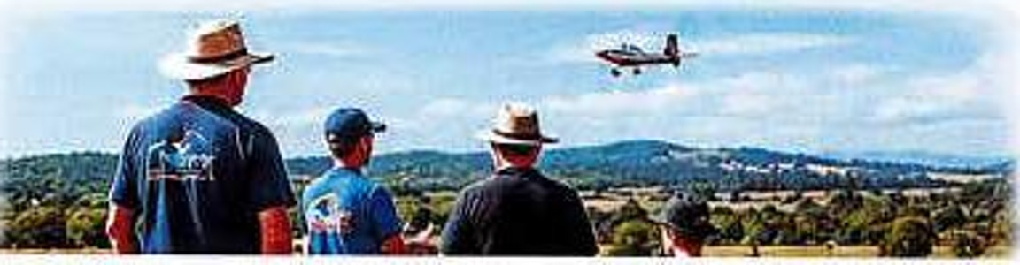
Come and see for yourself
The easiest way to judge how loud a model aircraft is, or how visible it is from a distance, is to see one flying. If you would like to visit, watch, or simply ask questions, get in touch — whether or not you support the application.
Suncoast Model Flyers Inc. · suncoastmodelflyers.com

